Information on tourist spots around Ojiya

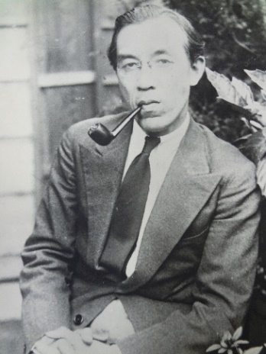
Junzaburō Nishiwaki

Junzaburō Nishiwaki is a world-famous poet, a scholar of English literature, and also a painter who was born in Ojiya. He loved the climate and the peaceful nature of Ojiya.

He was born on January 20th, 1894. He went to Ojiya high school, Keio Gijuku university and Oxford university, and then became a professor at Keio Gijuku University. Later he was a central figure of a new art movement in Japan.

He wrote lyrics of school songs for some schools in Ojiya: Ojiya high school, Ojiya west high school, Ojiya junior high school, Ojiya elementary school, and East Ojiya elementary school.

As a poet he was nominated for the Nobel Prize for Literature five times, and his poem has been acknowledged overseas until today. Additionally, he was endowed with a great skill of painting. His unique use of colors has outstanding reputation by art enthusiasts.

There are monuments of his poems at Mt. Yamamomo and Funaoka park. He was selected as a Honorary Citizen of Ojiya in 1964, and a Person of Cultural Merits in 1971.

